For the performance art, new music or community events section
FOR IMMEDIATE RELEASE: NEW YORK CITY
1687,Inc. presents Lenore Von Stein's
The Murder of Maryann Measles and the Murderers: based on a true story
Improvised and notated music and words using police records and newspaper accounts describe these events from the perspective of the victim and the victimizers as well as the authorities and the society as a whole.
For a newspaper's account:
http://www.ctnow.com/news/local/lc/hc-measles,0,5484350.storygallery?coll=hc-headlines-lc
This is part four of The Hidden Agenda and the Need to Know
The priorities and goals of a group in relationship to the goals of individuals within the group
Friday December 5, 2003 8PM Admission is $10
The Lesbian, Gay, Bisexual & Transgender Community Center
208 West 13th Street NYC
212-620-7310 www.gaycenter.org www.1687.org
1,2,3,9, A, or C to 14th Street
Lenore Von Stein (singer/composer) has been making collages using a mixture of musical disciplines and media for several years. Recent concert performances include the collage "There Is No Such Thing As Race" with Daniel Carter, and Rob Brown among many others, "What My Style is Made Of" and "Tolerating Ambition" with Tony Trischka. Von Stein originated the role in Samuel Beckett’s one-person piece, "The Expelled." Amanda MacBlane in the New Music Box called Von Stein’s recently released 1687 recording "I Haven’t Been Able To Lie And Tell The Truth" "Stark musical reality infused with energy." Lenore Von Stein's other recordings on the 1687 label are "Blind Love = PoRno?" and "Love Is Dead." "Tradition is in the eye of the beholder...surreal and uninhibited…somewhere between Cathy Berberian’s microtones and Ella Fitzgerald’s silky scats... strikingly offbeat lyrics, subtler, ever innovative." Kyle Gann & Gene Santoro, Village Voice & Pulse.
Daniel Carter (sax) has performed with Sun Ra, Billy Bang, William Parker, Roy Campbell, Sam Rivers, Sunny Murray, Hamiet Bluiett, Cecil Taylor, Matthew Shipp, Wilber Morris, Denis Charles, Medeski, Martin, & Wood, David S.Ware, Gunter Hampel, Merce Cunningham, Susie Ibarra, D.J. Logic and many others. "Urgent, introspective and melodic" All About Jazz
Rob Brown (sax) has performed with Cecil Taylor, Rashied Ali, Fred Hopkins, Mathew Shipp, William Parker, Tim Berne, Mark Dresser, Dennis Charles, Billy Bang, Borah Bergman and many others. "Brown's alto [on "Blue in Green"], mostly robust and earthy, cries with a quietly stoic sorrow..." Graham Lock, The Wire
Beth Griffith (soprano) has appeared with Sequentia, Musikfabrik, Ensemble13, L’Art pour L’Art, Cologne Radio Symphony Orchestra, and the Paris Nouvel Orchestra Philharmonique and has worked with composers John Cage, Morton Feldman, Mauricio Kagel and Karlheinz Stockhausen. Her one-hour, solo recording of Feldman’s "Three Voices" was awarded the German Record Critics Prize.
Reuben Radding (bass) has appeared with Elliott Sharp, John Zorn, Marc Ribot, Dave Douglas, Anthony Coleman, Roy Campbell, and many others. His recent recording "Luminescence" with Daniel Carter is on AUM Fidelity. "Radding bullies, slaps, and worries his bass like a half-bothered, fully curious black bear mauling a backpacker." --Peter Monahan, Earshot Jazz
With Andrew Bolotowsky, flutes
For photos, music samples and further information please contact: www.1687.org
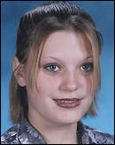
Maryann Measles

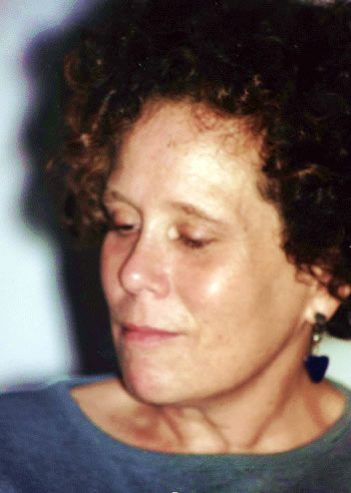
Lenore Von Stein

